COMSATS University Islamabad, Lahore Campus
Department of Computer Science
CSC241 - Object-Oriented Programming
LAB 02
Classes, Objects, Data Members & Member Functions
Student Name | ________________________________
Registration No. | CIIT-SP26-BAI-______-LHR
Program / Section | BSAI (BAI Section)
Semester | Fall 2026
Instructor | Muhammad Shahid Bhatti (Assistant Professor)
Lab Duration | 3 Hours
Execution Mode | Windows Command Prompt (javac / java)
Editor Used | Notepad
Working Folder | C:\CSC241\CIIT-SP26-BAI-001-LHR\Lab02
Submission | Lab02 folder pushed to GitHub
Date | ________________________________

1. Learning Outcomes
- Create Java classes and instantiate multiple objects using new Student() without defining constructors.
- Declare instance variables and demonstrate that different objects maintain independent state.
- Write instance methods that modify state, accept parameters, use local variables and return values.
- Apply Java naming conventions to classes, fields, variables, parameters and methods.
- Create and call valid overloaded methods and identify invalid overloads using method signatures.
- Demonstrate Java pass-by-value for primitives and for object-reference values.
- Compile and run multi-file Java programs from Windows Command Prompt and interpret compiler feedback.

2. Tools and Environment
All source files for this lab were written in Notepad only. No IDE Run button was used: every program was compiled with javac and executed with java from the Windows Command Prompt.
Operating System | Windows 11
Editor | Notepad (Windows built-in)
Compiler | javac (JDK 21)
Runtime | java (JDK 21)
Version Control | Git for Windows + GitHub
Terminal | Windows Command Prompt (cmd.exe)

Environment verification and folder setup
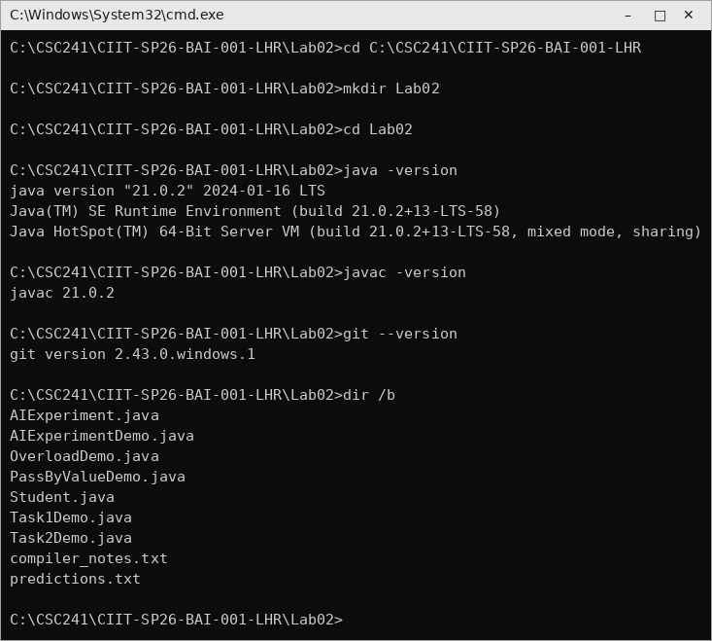
Figure 1 - Creating the Lab02 folder and verifying JDK and Git versions in Command Prompt.

3. Task 1 - Build a Class and Prove Independent Object State
Objective | Create three Student objects from one Student class and prove that each object holds its own state.
Concept focus | Class anatomy, object instantiation, reference variables, identity vs. state, instance variables.
Files | Student.java, Task1Demo.java
Evidence | Console output showing three independent objects before and after changing only one object.

3.1 Source Code
Student.java declares the three instance variables required by the task. The method bodies shown here are added in Task 2; in Task 1 only the fields are used.
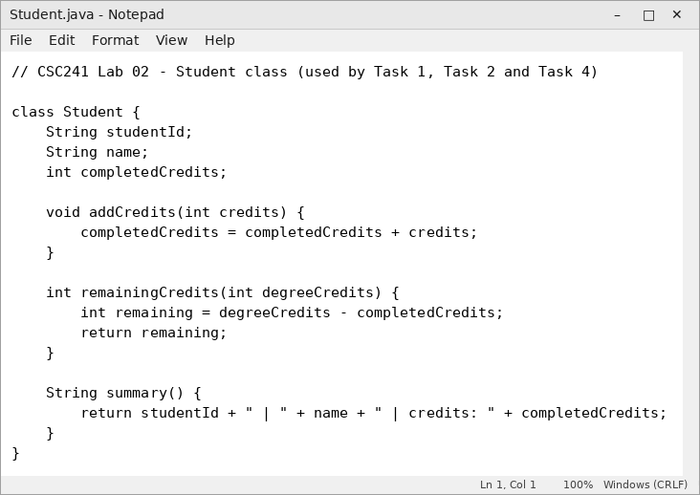
Figure 2 - Student.java opened in Notepad.
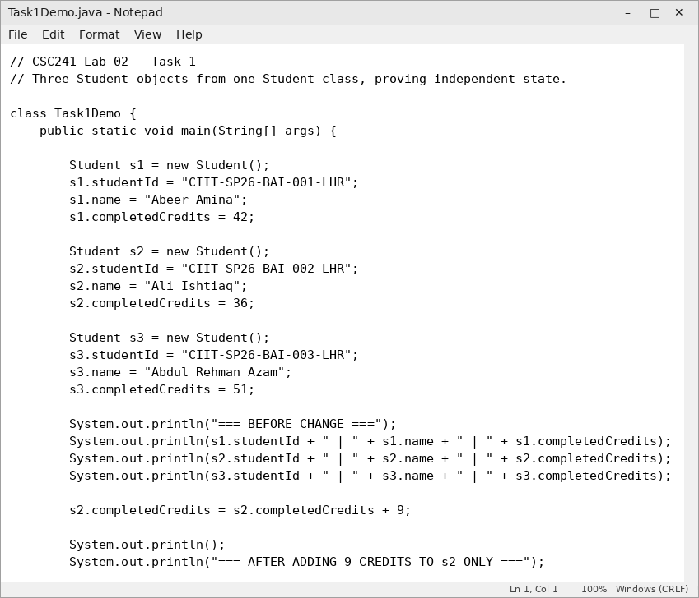
Figure 3 - Task1Demo.java in Notepad (part 1).
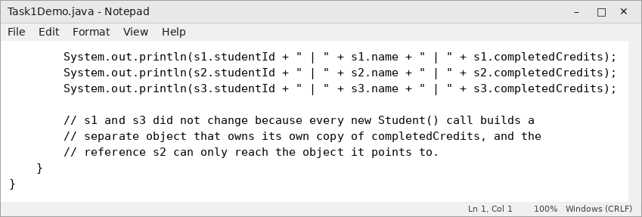
Figure 4 - Task1Demo.java in Notepad (part 2), including the two-line explanation comment.

3.2 Compilation and Output
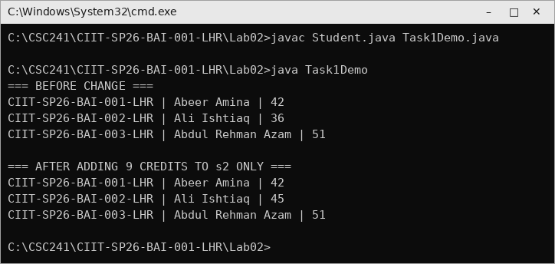
Figure 5 - Compiling and running Task 1 from Command Prompt.

3.3 Observation
Only s2.completedCredits changed from 36 to 45. The values held by s1 and s3 were untouched, which shows that each object created by new Student() owns a separate copy of the instance variables.

3.4 Task 1 Concept Check
1. What is the difference between the Student class and the objects s1, s2 and s3 created from it?
Answer: Student is the blueprint that defines which fields and methods every student will have, while s1, s2 and s3 are three separate objects built from that blueprint, each stored at its own memory location with its own values.
2. Why does changing s2.completedCredits not change the completedCredits value stored in s1 or s3?
Answer: Each new Student() call allocates a distinct object with its own completedCredits field, and the reference s2 can only reach the object it points to, so the assignment cannot touch the other two objects.
3. Which variables in Student represent persistent object state, and why are they instance variables rather than local variables?
Answer: studentId, name and completedCredits represent persistent state; they must keep their values for the whole lifetime of the object and differ per object, whereas a local variable would be created and destroyed with a single method call and could not be shared between methods.

4. Task 2 - Parameters, Local Variables and Return Values
Objective | Extend Student with addCredits(int), remainingCredits(int) and summary().
Concept focus | Instance methods, receiver object, parameters vs. arguments, local variables, void and non-void returns.
Files | Student.java (revised), Task2Demo.java
Evidence | Output proving state modification and returned results for two different objects.

4.1 Source Code
The three required methods are added to Student.java (Figure 2). addCredits is void and changes state, remainingCredits returns an int computed in the local variable remaining, and summary returns a readable String.
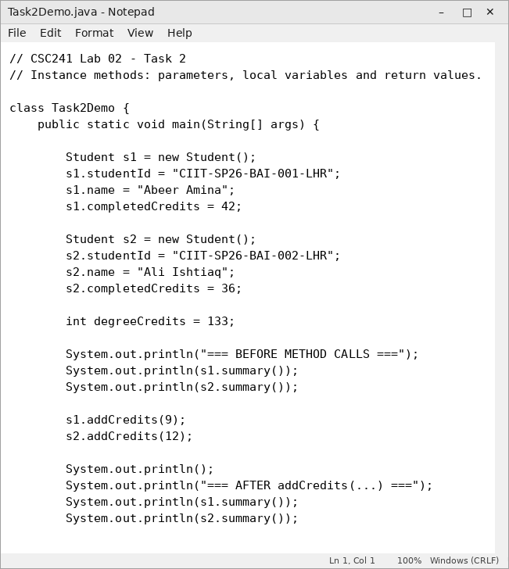
Figure 6 - Task2Demo.java in Notepad (part 1).
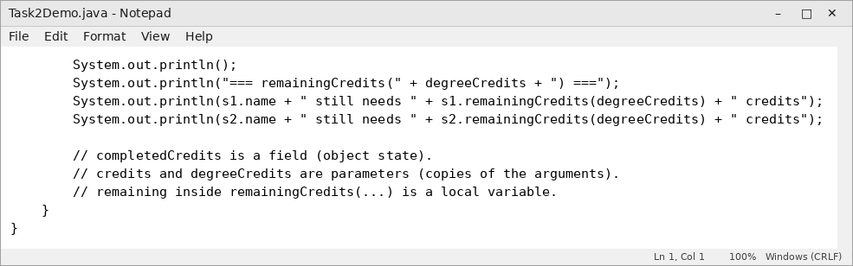
Figure 7 - Task2Demo.java in Notepad (part 2).

4.2 Compilation and Output
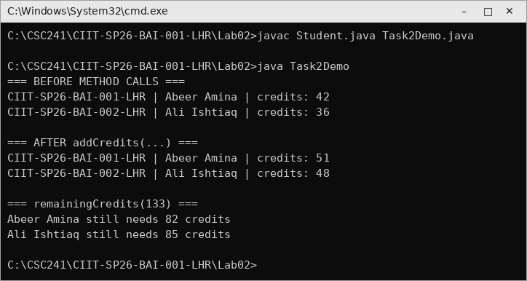
Figure 8 - Task 2 compiled and executed; both objects respond to the same methods with their own data.

4.3 Field, Parameter and Local Variable
- Field (object state): completedCredits, studentId, name - declared inside the class, outside every method.
- Parameter: credits in addCredits(int credits) and degreeCredits in remainingCredits(int degreeCredits) - a copy of the argument, alive only during the call.
- Local variable: remaining inside remainingCredits(...) - declared in the method body and discarded when the method returns.

4.4 Task 2 Concept Check
1. In addCredits(int credits), what is the difference between the parameter credits and the object field completedCredits?
Answer: credits is a temporary copy of the argument that exists only while the method runs, while completedCredits belongs to the receiver object and keeps its value after the method returns.
2. Why is remaining inside remainingCredits(...) better as a local variable than as an instance field?
Answer: It is only a scratch value used to compute one answer and has no meaning after the method returns, so storing it as a field would waste memory in every object and expose a value that is not real student state.
3. What information does the return type of remainingCredits(int degreeCredits) give to the caller?
Answer: It promises the caller that the method hands back a single int value, so the result can be stored in an int variable or printed and used directly in arithmetic.

5. Task 3 - Method Signatures and Overloading
Objective | Write three valid enroll overloads, attempt one invalid overload and record the compiler message.
Concept focus | Method signatures, parameter count/type/order, compile-time overload resolution, return type is not part of the signature.
Files | OverloadDemo.java, compiler_notes.txt
Evidence | Three valid calls executed, two invalid calls and one invalid overload explained with the javac message.

5.1 Method Signatures
enroll(String) // course code only, default section
enroll(String, int) // course code plus section number
enroll(int) // numeric course code

5.2 Source Code
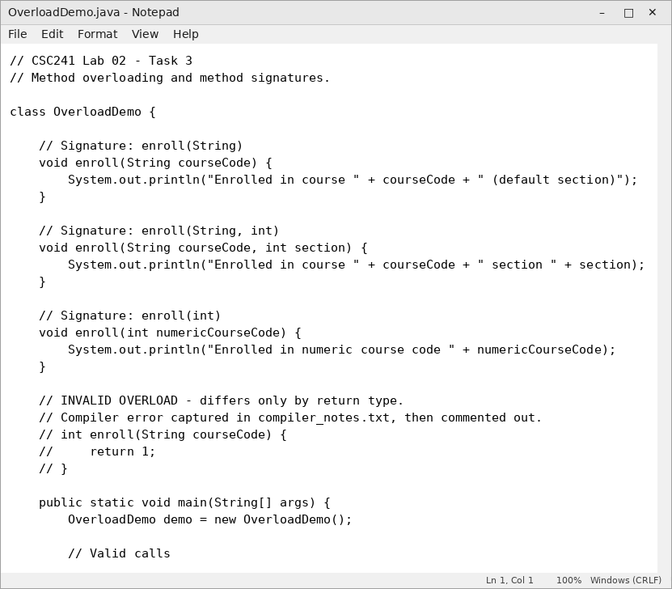
Figure 9 - OverloadDemo.java in Notepad (part 1): the three valid overloads with their signatures as comments.
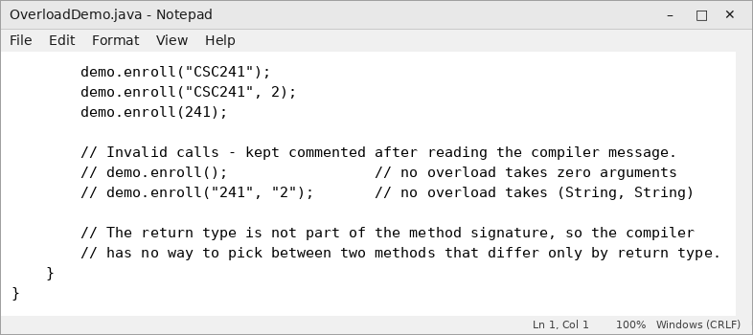
Figure 10 - OverloadDemo.java in Notepad (part 2): valid calls, plus the invalid calls commented out after the errors were recorded.

5.3 Output of the Valid Calls
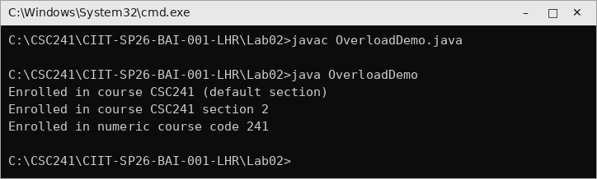
Figure 11 - Each call is matched to a different overload at compile time.

5.4 Invalid Overload and Compiler Feedback
An extra method int enroll(String courseCode) was added, differing from the existing enroll(String) only by return type. The compilation failed with the message below, which was recorded in compiler_notes.txt before the method was commented out.
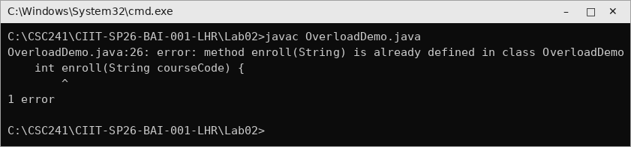
Figure 12 - javac rejects an overload that differs only by return type.
Why the return type cannot distinguish overloads: the signature is only the method name plus the parameter list, so at a call site such as enroll("CSC241") the compiler sees identical signatures and has no information to choose between them.

5.5 Prediction Table for the Five Calls
# | Call | Predicted result
1 | enroll("CSC241") | enroll(String) runs
2 | enroll("CSC241", 2) | enroll(String, int) runs
3 | enroll(241) | enroll(int) runs
4 | enroll() | Compile error - no zero-argument overload
5 | enroll("241", "2") | Compile error - no (String, String) overload

Stretch question: with show(long) and show(double) both present, the call show(10) selects show(long), because the int literal is widened to the narrower of the two applicable types.

5.6 Task 3 Concept Check
1. What is the method signature of enroll(String courseCode, int section)?
Answer: The signature is enroll(String, int) - the method name together with the ordered list of parameter types; the parameter names and the return type are not part of it.
2. Why are enroll(String) and enroll(int) valid overloads, while two methods with the same name and parameter types but different return types are not?
Answer: enroll(String) and enroll(int) have different parameter types, so the compiler can decide from the argument at the call site; if only the return type differs the signatures are identical and a call gives the compiler nothing to distinguish them by, especially when the returned value is ignored.
3. For the call enroll("CSC241", 2), which overload should the compiler select, and what information does it use to make that decision?
Answer: It selects enroll(String, int), using the number, types and order of the arguments at compile time to match the most specific applicable signature.

6. Task 4 - Prove Java Pass-by-Value
Objective | Run three controlled experiments on a primitive, an object mutation and a parameter reassignment.
Concept focus | Primitive values are copied; reference values are also copied; mutation differs from reassignment.
Files | PassByValueDemo.java, Student.java, predictions.txt
Evidence | Before, Inside Method and After values printed for all three experiments.

6.1 Source Code
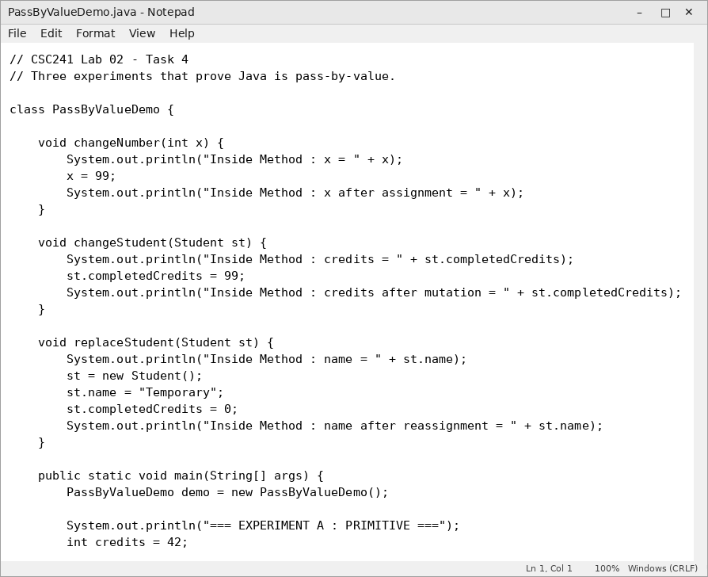
Figure 13 - PassByValueDemo.java in Notepad (part 1): the three helper methods.
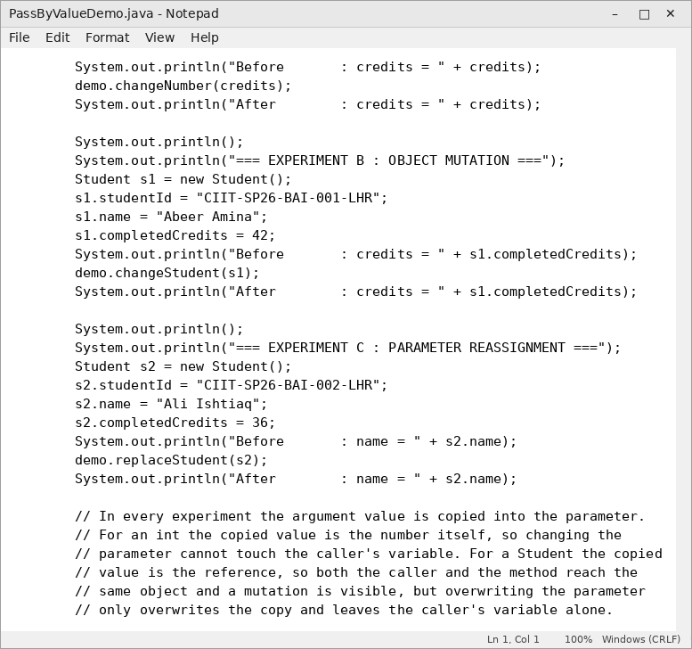
Figure 14 - PassByValueDemo.java in Notepad (part 2): Experiments A and B.
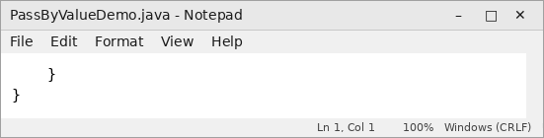
Figure 15 - PassByValueDemo.java in Notepad (part 3): Experiment C and the written explanation.

6.2 Compilation and Output
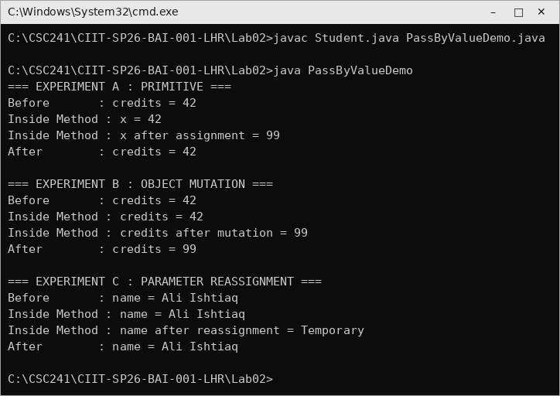
Figure 16 - All three experiments executed from Command Prompt.

6.3 Before / Inside Method / After
Exp. | What the method does | Before | Inside | After
A | changeNumber(int x) assigns x = 99 | 42 | 42 then 99 | 42
B | changeStudent(Student st) sets st.completedCredits = 99 | 42 | 42 then 99 | 99
C | replaceStudent(Student st) assigns st = new Student() | Ali Ishtiaq | Ali Ishtiaq then Temporary | Ali Ishtiaq

6.4 Required Explanation
In every one of the three experiments the argument value is copied into the parameter. In Experiment A the copied value is the number 42 itself, so writing 99 into the parameter changes only the copy and the caller still sees 42.
In Experiment B the copied value is a reference, that is, the address of the Student object. The copy points at exactly the same object as the caller variable, so following that reference and writing to st.completedCredits modifies the one shared object and the caller observes 99.
In Experiment C the method overwrites the parameter itself with a reference to a brand new Student. Because the parameter is only a copy, overwriting it breaks the link to the original object without touching the caller variable, which still refers to the original Student and still prints Ali Ishtiaq. This is exactly why changeStudent(...) can affect the object while replaceStudent(...) cannot redirect the caller variable, and why it is wrong to say that Java passes objects by reference.

6.5 Task 4 Concept Check
1. After changeNumber(int x) assigns x = 99, why does the caller’s original int variable keep its old value?
Answer: Because the argument value is copied into the parameter, so x is an independent copy living in the method’s own stack frame and assigning to it has no path back to the caller’s variable.
2. If a Student reference is passed to a method, why can changing st.completedCredits be visible to the caller?
Answer: The copied value is the reference, so the parameter points at the very same object on the heap; mutating a field through that reference changes the single shared object that the caller is also looking at.
3. Why does assigning st = new Student() inside a method not make the caller’s variable refer to the new Student object?
Answer: That assignment replaces only the method’s local copy of the reference; the caller’s variable is a separate storage location that still holds the original reference, so it keeps pointing at the original object.

7. Task 5 - Integrated BAI Challenge: AIExperiment
Scenario | A BAI student tracks the progress of small AI experiments and needs a class that stores experiment state and updates or queries it.
Files | AIExperiment.java, AIExperimentDemo.java
Constraints | No constructors, private fields, getters/setters, inheritance, arrays, interfaces, exceptions, file I/O or static members beyond main.

7.1 Requirement Coverage
ID | Requirement | Where it is met
R1 | Class AIExperiment with experimentName, completedEpochs, targetEpochs | AIExperiment.java, lines 4-6
R2 | At least two independent objects with explicit field values | AIExperimentDemo.main - first, second
R3 | void runEpochs(int epochs) | AIExperiment.java
R4 | Overloaded runEpochs(int, int) | AIExperiment.java
R5 | int remainingEpochs() | AIExperiment.java
R6 | String status() | AIExperiment.java
R7 | Local variable inside a method | totalEpochs in runEpochs(int, int); remaining in remainingEpochs()
R8 | Changing one experiment does not change the other | Output sections 2 and 3
R9 | Helper method mutates a passed object | trainExtra(AIExperiment, int)
R10 | Naming conventions and predictions written first | predictions.txt

7.2 Source Code
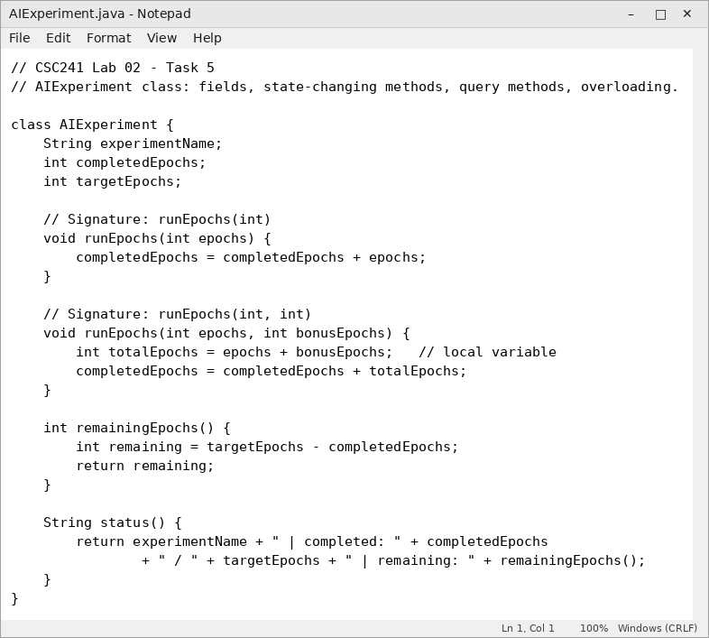
Figure 17 - AIExperiment.java in Notepad.
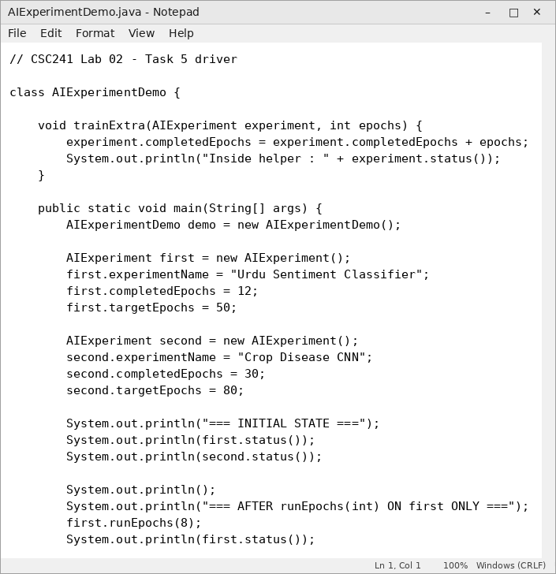
Figure 18 - AIExperimentDemo.java in Notepad (part 1).
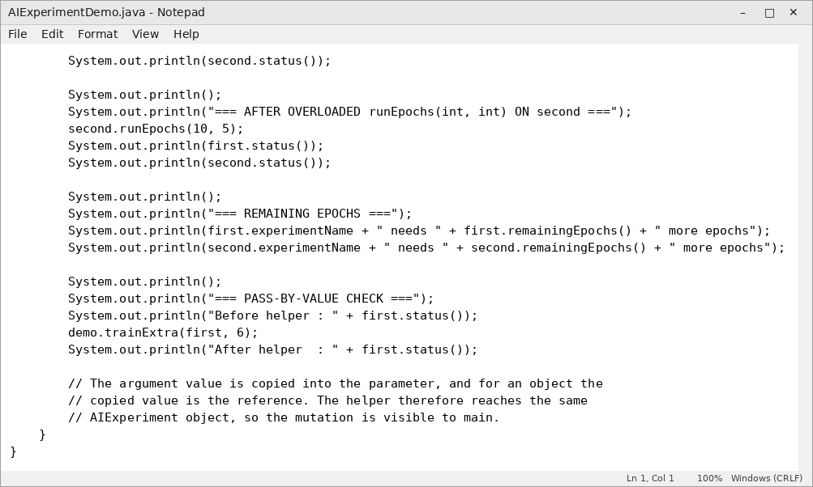
Figure 19 - AIExperimentDemo.java in Notepad (part 2).

7.3 Compilation and Output
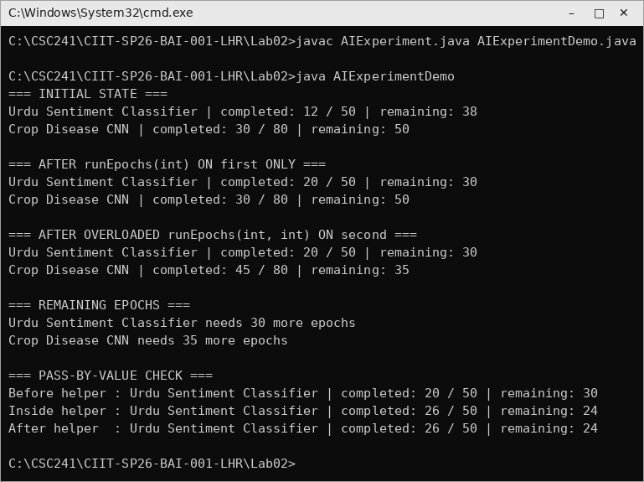
Figure 20 - Initial state, method calls, remaining epochs, status text and the pass-by-value check.

7.4 Observation
Running eight epochs on the first experiment moved it from 12/50 to 20/50 while the second stayed at 30/80, and the overloaded call runEpochs(10, 5) moved the second to 45/80 while the first stayed at 20/50. When first was passed to trainExtra(...), the new value 26/50 was visible both inside the helper and after it returned, because the argument value is copied into the parameter and for an object that copied value is a reference to the same object.

7.5 Task 5 Concept Check
1. In AIExperiment, which data should be stored as instance variables, and which calculations should remain local to methods?
Answer: experimentName, completedEpochs and targetEpochs are real per-object state and belong in instance variables, while intermediate results such as totalEpochs and remaining are recomputed on demand and belong in local variables.
2. Identify one method that changes object state and one that only computes or returns information.
Answer: runEpochs(int) changes state by increasing completedEpochs, while remainingEpochs() only computes targetEpochs - completedEpochs and returns it without modifying the object.
3. If you created overloaded methods in this task, state their signatures and explain why the compiler can distinguish them.
Answer: The signatures are runEpochs(int) and runEpochs(int, int); they differ in the number of parameters, so the compiler can match each call to exactly one method from the argument list at compile time.

8. Supporting Evidence Files

8.1 predictions.txt (written before every run)
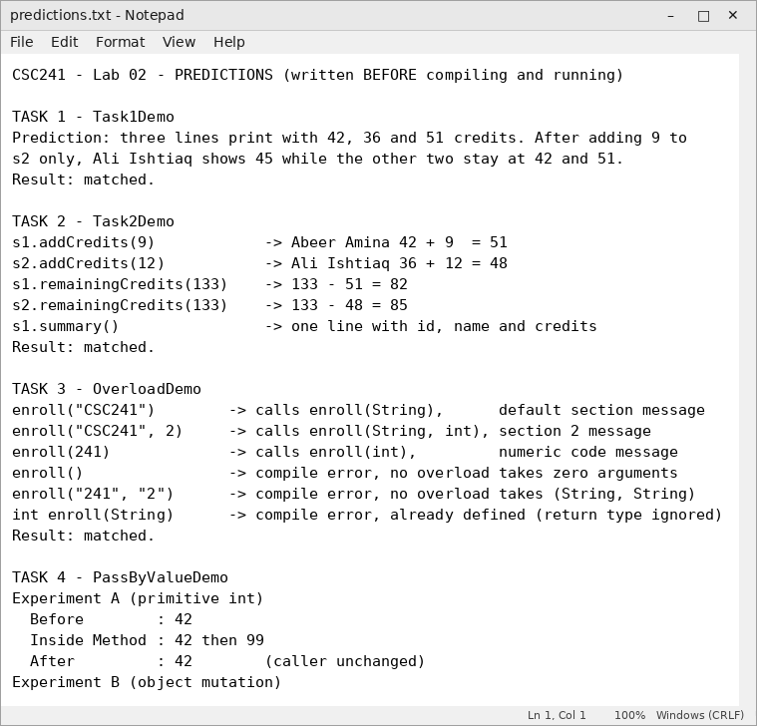
Figure 21 - predictions.txt in Notepad (part 1).
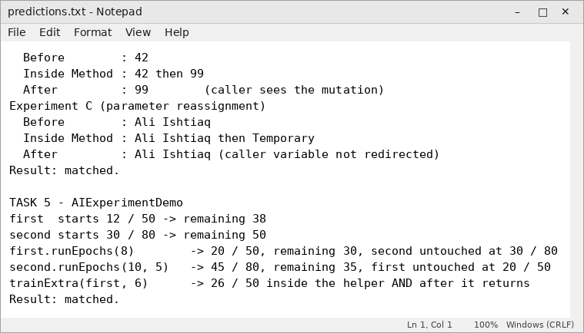
Figure 22 - predictions.txt in Notepad (part 2).

8.2 compiler_notes.txt
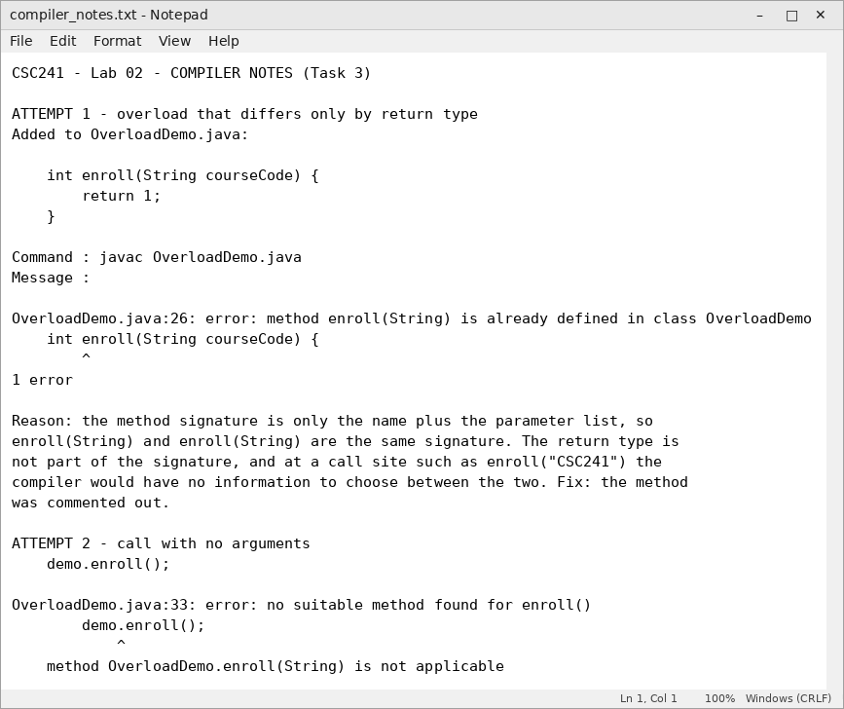
Figure 23 - compiler_notes.txt in Notepad (part 1).
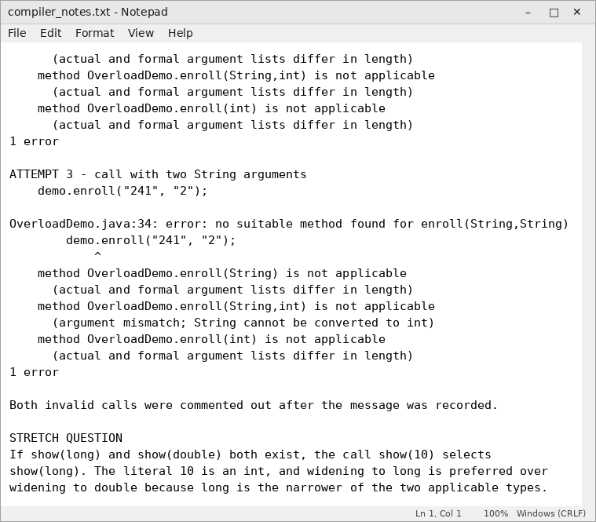
Figure 24 - compiler_notes.txt in Notepad (part 2).

9. GitHub Checkpoint and Submission Evidence
The Lab02 folder was committed to the repository created in Lab 01 using two meaningful commits. The .gitignore from Lab 01 keeps *.class ignored, so no compiled class files were uploaded.
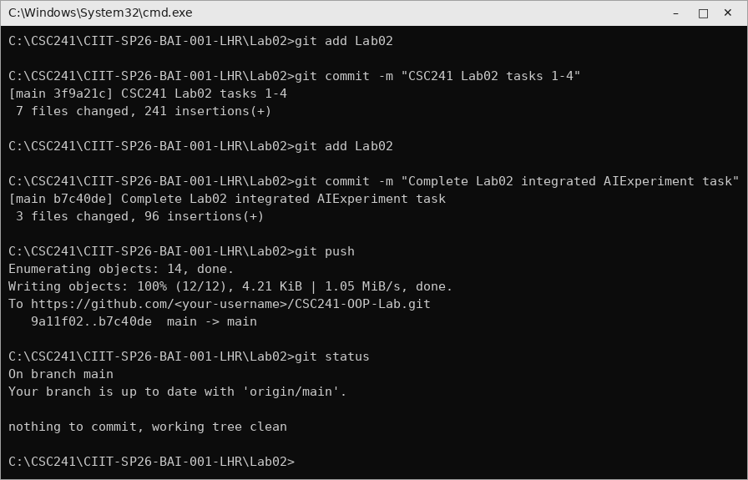
Figure 25 - Two commits and a successful push from Command Prompt.

9.1 Submission Checklist
# | File required in Lab02 | Status
1 | Student.java | Included
2 | Task1Demo.java | Included
3 | Task2Demo.java | Included
4 | OverloadDemo.java | Included
5 | PassByValueDemo.java | Included
6 | AIExperiment.java | Included
7 | AIExperimentDemo.java | Included
8 | predictions.txt | Included
9 | compiler_notes.txt | Included
10 | *.class files | Excluded via .gitignore

Repository link: ____________________________________________

10. Five-Minute Exit Check
1. What is the difference between a class and an object?
Answer: A class is the blueprint describing the fields and methods, while an object is a concrete instance created from that blueprint at run time with its own copy of the fields.
2. Why does changing s1.completedCredits not change s2.completedCredits?
Answer: Each object has its own completedCredits field in its own memory, and s1 reaches only the object it refers to.
3. What is the method signature of enroll(String, int)?
Answer: enroll(String, int) - the name plus the ordered parameter types, excluding parameter names and the return type.
4. Why can two methods not be overloaded by return type alone?
Answer: The return type is not part of the signature, so two such methods would have the same signature and the compiler could not decide which one a call refers to.
5. Why can a method mutate an object through a copied reference value but not reassign the caller’s reference variable?
Answer: The copied reference still points to the same object, so field mutations are shared; but reassigning the parameter overwrites only the copy, leaving the caller’s separate variable pointing at the original object.

11. Conclusion
This lab showed that a single class can produce many objects that each carry independent state, that instance methods use parameters and local variables to operate on the receiver object and return results to the caller, and that overload resolution depends on the signature rather than the return type. The three pass-by-value experiments confirmed that Java always copies the argument value into the parameter, which explains why a primitive assignment is invisible to the caller, an object mutation is visible, and a parameter reassignment cannot redirect the caller’s variable. All programs were compiled with javac and executed with java from the Windows Command Prompt, with every source file edited in Notepad.

